

Analyze the trends and issues that influence the development of philosophy in their clinical nursing practice/management
No4





- Stress is usually defined from a ‘demand-perception response perspective (Bartlett 1998). Lazarus and Folk man (1984) integrated this view into a cognitive theory of stress that has become the most widely applied theory in the study occupational stress and stress management (Lehrer & Wool folk 1993, Rick & Pen-ewe 1995). The basic concept is that stress relates both to an individual’s perception of the demands being made on them and to their perception of their capability to meet those demands (Clancy & Mc Vicar 2002).
- An individual’s stress threshold, sometimes referred to as stress ‘hardiness’, is likely to be dependent upon their characteristics, experiences and coping mechanisms, and also on the circumstances under which demands are being made. A single event, therefore, may not necessarily constitute a source of stress (i.e. be a ‘stressor’) for all nurses, or for a particular individual at all times.
- Assessing stress is likely to be very difficult in an occupation as diverse and challenging as health care, yet the effectiveness of organizational interventions to reduce or eliminate sources of stress depends upon a sound understanding of the stress phenomenon for nurses. This reviews the implications of the subjective aspects of stress perception for nurses who, with teachers and managers, are a professional group most likely to report very high levels of workplace stress (Smith et al. 2000).
- It is the transition to serve distress that is likely to be most detrimental for nurses, and is closely linked to staff absenteeism, poor staff retention, and ill-health (Healy & McKay 1999, McGowan 2001, Shader et al. 2001). If serve distress is to be prevented, then it is important to understand what factors promote the transition. Nursing provides a wide range of potential workplace stressors as it is a profession that requires a high level of skill, team working in a variety of situations, provision of 24-hour delivery of care, and input of what is often referred to as ‘emotional labor’ (Phillips 1996).

Identified nine sub-scales of workplace stressors that might impact on nurses. These are:

Stress in the workplace…
Stress is something when people feel they are unable to cope with the pressures or demands upon them. This feeling is a natural reaction to excessive pressure or even to excessive boredom. It isn’t disease, but if stress is excessive and goes on for some time, it can lead to mental and physical ill health.
- Occupational stress is quickly becoming the single greatest cause of occupational disease (Leigh and Schnall, 2000+) and can have far-reaching consequences for both the worker and the workplace. Occupational stress occurs when external demands and conditions do not match a person’s needs, expectations or ideals or exceed their physical capacity, skills, or knowledge for comfortably handling a situation (French et al., 1982).
- For employees, chronic exposure to stressful situation such as work overload, poor supervisory support and low input into decision-making have been cross-sectionally and prospectively linked to a range of debilitating health outcomes, including depression, anxiety, emotional exhaustion, immune deficiency disorders and cardiovascular disease (Michie and Williams, 2003+; Sapolsky, 2003+).
Common causes of work-related stress include…

Common causes of work-related stress include (cont)…

Health effects of stress

When a person is exposed to chronic, prolonged work-related stress, they may experience physical and psychological symptoms such as:
- Frequent headaches
- Back aches and other muscular aches and pains
- Cramps in the neck, shoulders or arms
- Poor memory, troubles concentrating
- Feeling frustrated and irritable or angry
- Feeling weepy or tearful Asthma
- Loss of energy and motivation
Health effects of stress
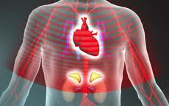
When a person is exposed to chronic, prolonged work-related stress, they may experience physical and psychological symptoms such as:
- Feeling anxious, helpless or afraid
- Apathy and hopelessness
- Changes in appetite and weight
- Sleep difficulties
- Continual tiredness, even exhaustion
- Generally feeling worn out or run down
- Most people react to same kinds of stress in similar ways. To be affected by work-related stress is not a sign of personal weakness. It’s common for employers to blame workers for being stressed or to talk about workers needing to have better ‘coping’ skills
- Workers report job insecurity, understanding, increasing workloads, longer hours and poor
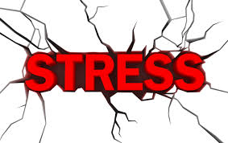
- Management action those are consistent with organizational values.

- Stress prevention policies: Stress prevention policies should be developed jointly by employers and workers and their representatives. Employers need to provide information, training and advice to workers and supervisors.
- Policies should focus on good work organization and ensure that work-related stress is approached in the same way as other health and safety hazards at work. Where possible, the hazard should be eliminated. If hazards cannot be eliminated, they should be minimized better ways of organizing work should be found that eliminated or reduce the causes of work-related stress.
Basic steps in eliminating or reducing work-related stress include…
Some basic steps in eliminating or reducing work-related stress include:
- Management styles are consultative, so that workers participate in determining the expectations of the job and the arrangement of their own work situation.
- Pay arrangements do not encourage excessive overtime and unpaid overtime is discouraged and is compensated quickly with time off in lieu.
- Work hours, including shift schedule, rest breaks and overtime arrangements are structured to ensure adequate rest recuperation from the physical and mental effect of work.



A 2013 survey by APA's Center for Organizational Excellence also found that job-related stress is a serious issue. More than one-third of working Americans reported experiencing chronic work stress and just 36 percent said their organizations provide sufficient resources to help them manage that stress.
You can't always avoid the tensions that occur on the job. Yet you can take steps to manage work-related stress.

Common Sources of Work Stress
Certain factors tend to go hand-in-hand with work-related stress. Some common workplace stressors are:
- Low salaries.
- Excessive workloads.
- Few opportunities for growth or advancement.
- Work that isn't engaging or challenging.
- Lack of social support.
- Not having enough control over job-related decisions.
- Conflicting demands or unclear performance expectations.

Effects of Uncontrolled Stress
Unfortunately, work-related stress doesn't just disappear when you head home for the day. When stress persists, it can take a toll on your health and well-being.
In the short term, a stressful work environment can contribute to problems such as headache, stomachache, sleep disturbances, short temper and difficulty concentrating. Chronic stress can result in anxiety, insomnia, high blood pressure and a weakened immune system. It can also contribute to health conditions such as depression, obesity and heart disease. Compounding the problem, people who experience excessive stress often deal with it in unhealthy ways such as overeating, eating unhealthy foods, smoking cigarettes or abusing drugs and alcohol.

Taking Steps to Manage Stress
- Track your stressors. Keep a journal for a week or two to identify which situations create the most stress and how you respond to them. Record your thoughts, feelings and information about the environment, including the people and circumstances involved, the physical setting and how you reacted. Did you raise your voice? Get a snack from the vending machine? Go for a walk? Taking notes can help you find patterns among your stressors and your reactions to them.
- Develop healthy responses. Instead of attempting to fight stress with fast food or alcohol, do your best to make healthy choices when you feel the tension rise. Exercise is a great stress-buster. Yoga can be an excellent choice, but any form of physical activity is beneficial. Also make time for hobbies and favorite activities. Whether it's reading a novel, going to concerts or playing games with your family, make sure to set aside time for the things that bring you pleasure. Getting enough good-quality sleep is also important for effective stress management. Build healthy sleep habits by limiting your caffeine intake late in the day and minimizing stimulating activities, such as computer and television use, at night.
- Establish boundaries. In today's digital world, it's easy to feel pressure to be available 24 hours a day. Establish some work-life boundaries for yourself. That might mean making a rule not to check email from home in the evening, or not answering the phone during dinner. Although people have different preferences when it comes to how much they blend their work and home life, creating some clear boundaries between these realms can reduce the potential for work-life conflict and the stress that goes with it.
- Take time to recharge. To avoid the negative effects of chronic stress and burnout, we need time to replenish and return to our pre-stress level of functioning. This recovery process requires “switching off” from work by having periods of time when you are neither engaging in work-related activities, nor thinking about work. That's why it's critical that you disconnect from time to time, in a way that fits your needs and preferences. Don't let your vacation days go to waste. When possible, take time off to relax and unwind, so you come back to work feeling reinvigorated and ready to perform at your best. When you're not able to take time off, get a quick boost by turning off your smartphone and focusing your attention on non-work activities for a while.
- Learn how to relax. Techniques such as meditation, deep breathing exercises and mindfulness (a state in which you actively observe present experiences and thoughts without judging them) can help melt away stress. Start by taking a few minutes each day to focus on a simple activity like breathing, walking or enjoying a meal. The skill of being able to focus purposefully on a single activity without distraction will get stronger with practice and you'll find that you can apply it to many different aspects of your life.
- Talk to your supervisor. Healthy employees are typically more productive, so your boss has an incentive to create a work environment that promotes employee well-being. Start by having an open conversation with your supervisor. The purpose of this isn't to lay out a list of complaints, but rather to come up with an effective plan for managing the stressors you've identified, so you can perform at your best on the job. While some parts of the plan may be designed to help you improve your skills in areas such as time management, other elements might include identifying employer-sponsored wellness resources you can tap into, clarifying what's expected of you, getting necessary resources or support from colleagues, enriching your job to include more challenging or meaningful tasks, or making changes to your physical workspace to make it more comfortable and reduce strain.
- Get some support. Accepting help from trusted friends and family members can improve your ability to manage stress. Your employer may also have stress management resources available through an employee assistance program (EAP), including online information, available counseling and referral to mental health professionals, if needed. If you continue to feel overwhelmed by work stress, you may want to talk to a psychologist, who can help you better manage stress and change unhealthy behavior.
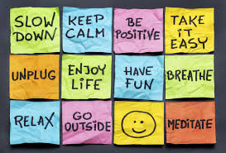

How to Prevent Job Stress
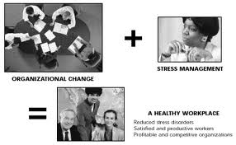

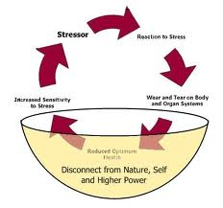

Tips for alleviating the effects of work-related stress:
- Although removing or controlling the causes of work-related stress is essential to ensure a safe working environment, it is not always possible for the worker to quickly or easily remove stressors form the work place.
- The stress alleviation techniques describe below may assist people who are unable to escape from the work stresses to reduce the effect of stress on their health, eat regularly and well. Stressful working enjoinment may means that people skip breaks at work, including lunch and other meal breaks.
Take regular exercise:

- Regular exercise in important for maintaining good health. Exercise and maintaining physical fitness can reduce the severity of our response to stressful events. Aerobic exercise can also reduce musculoskeletal and psychological symptom associated with stress.
- Relaxation techniques
- If practiced regularly, relaxation and
- Meditation techniques have also been shown to mitigate stress response.
- Get a good night`s sleep
- One block of 7 to 8 hour’s uninterrupted sleep per day is preferable. Avoid strenuous exercise in the last one to two hours before bedtime, as it raises the heart rate and makes sleep more difficult. Avoid caffeine other stimulants close to bed time.
Family and social life:
- Feeling too tired and/or having a lack of interest in social and/or family life is frequently reported as a consequence of work related stress. Irritability and /or difficulty in switching off from work may also negatively affect personal and social relationships. Additional effort and planning tospend time with family and friends and to make time for hobbies and other non-work-related activities may be necessary to overcome this risk.
- Limit the use of tobacco, alcohol and other drugs. Alcohol within one to two hours of bedtime can lead to disrupted sleep pattern, as can
- Caffeine found in high concentration in coffee and many soft drinks.
External Forces & Issues Driving Nursing Education:
- MDG’s
- Global issues
- Global violence
- Demographic changes
- Technological advances
- Globalization
- Environmental challenges
- WHO Standards for Basic Nursing Education (2009)
- Nursing care delivery systems
- Nursing shortage
- New and emerging degrees
- 21 competencies for the 21st century (Bellack& O’Neil, 2000)
Strategies to identify Forces and Issues in related to Nursing Education:
- Comparison of WHO Standards with nursing education programs in Indonesia
- Environmental scan
- Forecasting
- Epidemiology
- Survey research/Consensus building

Learning & Education Theories:
- Boyer’s Scholarship of Engagement
- Kolb’s Learning Cycle
- Bloom’s taxonomy of learning objectives
- Knowles’s adult learning theory
Components of Curriculum Development and Design:
- Type of undergraduate nursing program: diploma, associate or baccalaureate degree
- Curriculum design:
- Blocked content
- Integrated content
- Sequencing of courses (master plan)

Use of Theory in Curriculum Development:
- Single specific nursing theory or model
- Concepts from multiple theories or models
Next Steps
- Mission

- Vision
- Core Values
- Philosophy
- Competencies (with leveling)
- Curriculum outcomes
- Quality improvement activities

Teaching Approaches:
- Lecture
- Problem-based learning
- Competency-based learning
- Concept mapping
- Portfolio
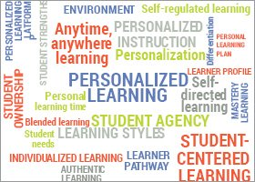
- Self-learning packets
Student Learning Styles:
- Characteristics of the learner
- Diversity of learners
- Learning style preferences
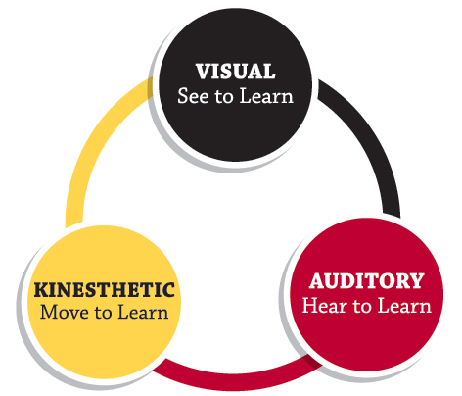
Types of Learners:
- Visual (25%)
- Auditory (30%)

- Kinesthetic (45%)



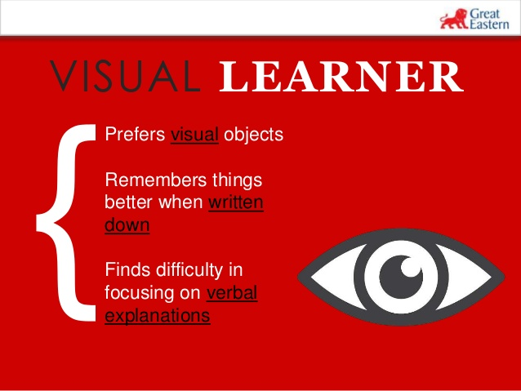

Learning Style | Knowledge Retention
- Lecture  - Reading  - Audio-visual  - Demonstration  - Discussion group  - Practice by doing  - Teaching others  - Immediate application in real situation  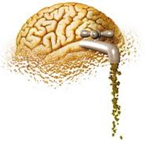 | - 10%  - 20%  - 30%  - 50%  - 75%  - 85%  - 90%  - 90%  (National Training Laboratory  Institute, Alexandria, VA, 2006)


Art:
- Audio clips
- Video clips
- Photography
- Artwork


Memory Aides:
- Acronym
- Visual aides
- Poetry
- Music
- Games

Future Trends & Issues in Nursing Education:
- Increased collaboration between nursing practice and nursing education
- Increased emphasis on collaboration between healthcare disciplines
- Increased development of educational products for faculty and students
- Increased student and nurse mobility (including increased licensure mobility)
- Increased distance (online) learning
- Schools of nursing providing ongoing professional development for competence requirements
- Increased teaching of evidence-based practice.
- Positive role of media
- Political leadership
Trends and issues in Nursing Education/management
- Stress is usually defined from a ‘demand-perception response perspective (Bartlett 1998). Lazarus and Folk man (1984) integrated this view into a cognitive theory of stress that has become the most widely applied theory in the study occupational stress and stress management (Lehrer & Wool folk 1993, Rick & Pen-ewe 1995). The basic concept is that stress relates both to an individual’s perception of the demands being made on them and to their perception of their capability to meet those demands (Clancy & Mc Vicar 2002).
- An individual’s stress threshold, sometimes referred to as stress ‘hardiness’, is likely to be dependent upon their characteristics, experiences and coping mechanisms, and also on the circumstances under which demands are being made. A single event, therefore, may not necessarily constitute a source of stress (i.e. be a ‘stressor’) for all nurses, or for a particular individual at all times.

